# History of Document

|  |  |  |  |
| --- | --- | --- | --- |
| **Version** | **Date** | **Author(s)** | **Revision Notes** |
| 1.0 | 2016-09-12 | Phuong | Initiate Document |
| 1.0 | 2016-09-26 | Phuong | Add Pattern Document |

# General Rules

|  |  |  |
| --- | --- | --- |
| **Index** | **Item** | **Rule** |
| 1 | Number Calculation | * Number’s value after “decimal point” will be rounded up to 2 significant digits * Example:   + 3.14159 will be rounded up to 3.14   + 3.14759 will be rounded up to 3.15   + 0. 00314159 will be rounded up to 0.0031   + 0.00316759 will be rounded up to 0.0032 |

# Product

## Pattern

### Pattern List

1. Pattern List
   1. Main Screen
   2. Component
2. Add New Pattern
   1. Main Screen
   2. Component

### Pattern Detail

1. General Information
   1. Main Screen
   2. Component
2. Pattern Parts
   1. Main Screen
   2. Component
3. Pattern Variation
   1. Main Screen
   2. Component
4. Pattern Comment

# Costing

## Costing List

### Create by Copy

1. Main Screen of “Create by Copy”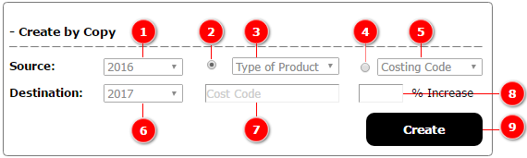
2. Components

|  |  |  |
| --- | --- | --- |
| **Component** | **Type** | **Description** |
| (1) | Dropdown Box | List of source Seasons |
| (2) | Radio Button | Choose to copy from Type of Product |
| (3) | Dropdown Box | Type of Proudcts, just have 1 option: ALL |
| (4) | Radio Button | Choose to copy from Costing Code |
| (5) | Dropdown Box | Cost Codes which includes: ALL and list of specific costing codes (ex: TSL, TSS...) |
| (6) | Dropdown Box | Destination Seasons |
| (7) | Text Field | Destination Costing’s code. |
| (8) | Text Field | An increase of (%) in Costing Version’s Factory Cost |
| (9) | Button | User click on this button to create new Costing with new input values. All source Costing’s versions will be automatically copied to new Costing. |

1. Business Rules

|  |  |  |  |  |  |
| --- | --- | --- | --- | --- | --- |
| **Radio Button**  **(2)** | **Type of Products  (3)** | **Radio Button (4)** | **Costing Code**  **(5)** | | **Action** |
| CHECKED | ALL |  | |  | **(5)**: Disabled  **(7)**: Disabled  **(8)**: Disabled   * Copy all Costing Codes from source season with BLANK values to destination season:   + Weight: empty   + Volume: empty * Do not allow to create duplicated code |
|  |  | CHECKED | | ALL | (**3**): Disabled  (**7**): Disabled  (**8**): Enabled   * Copy all Costing Codes which have **PRICE LIST = YES** along with their figures (Weight, Volume) from source season to destination season * Copy all Costing Versions of each Costing from source season to destination season and recalculate the Factory Cost according to % increased:   + New Factory Cost = Source’s Factory Cost * (1 + **(8)**/100) * Do not allow to create duplidated code |
|  |  | CHECKED | | Specific value (ex: TSL) | (**7**): Enabled  (**8**): Enabled   * Copy Costing’s figures (Weight, Volume) from source season to destination season * Copy all Costing Versions being chosen Costing to destination season and recalculate the Factory Cost according to % increased:   + New Factory Cost = Source’s Factory Cost * (1 + **(8)**/100) * Do not allow to create duplidated code |

# Price List

## Price List Factory

### Price List Factory List

#### Create New Price List Factory

1. Main Screen

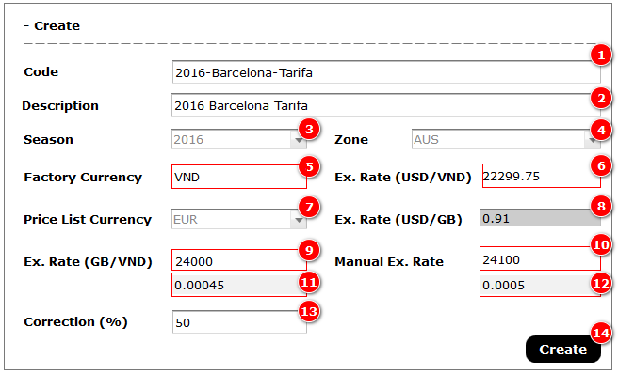

1. Components

|  |  |  |
| --- | --- | --- |
| **Component** | **Type** | **Description** |
| (1) | Text Field | Price List (P.L.) Code |
| (2) | Text Field | P.L.’s Description |
| (3) | Dropdown Box | P.L.’s Season |
| (4) | Dropdown Box | P.L.’s Zone |
| (5) | Label | Factory’s Currency |
| (6) | Label | Factory’s exchange rate based on USD |
| (7) | Dropdown Box | P.L.’s Currency |
| (8) | Label | P.L.’s exchange rate based on USD |
| (9) | Label | Rate between Factory’s currency and P.L.’s currency.  (**9**) = (**6**) divided by (**8**) |
| (10) | Text Field | Manual rate between Factory’s currency and P.L.’s currency |
| (11) | Label | Inverse number of (**9**).  (**11**) = 1 / (**9**) |
| (12) | Label | Inverse number of (**10**).  (**12**) = 1/ (**10**) |
| (13) | Text Field | P.L.’s Correction |
| (14) | Button | User clicks on this button to create new P.L. Factory |

1. Business Rules

|  |  |  |
| --- | --- | --- |
| **Index** | **Action** | **Rule** |
| 1 | Create new P.L. | * Price’s calculation is always based one muanual exchange rate (**10**) |
| 2 | Update P.L.’s figures | * Updating P.L. Factory’s figures won’t effect to it’s manual prices * Updating P.L. Factory’s figures won’t effect to P.L. Zone’s munual prices |

#### Create New Price List Factory by Copy

1. Main Screen

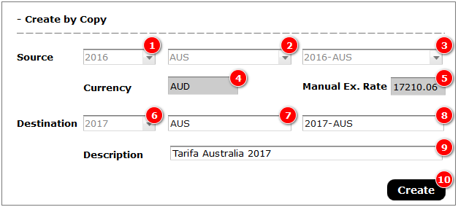

1. Components

|  |  |  |
| --- | --- | --- |
| **Component** | **Type** | **Description** |
| (1) | Dropdown Box | Source’s Seasons |
| (2) | Dropdown Box | Source’s Zones |
| (3) | Dropdown Box | Source’s P.L. Factory |
| (4) | Label | Source’s P.L. Factory’s currency |
| (5) | Label | Source P.L. Factory’s manual exchange rate |
| (6) | Dropdown Box | Destination’s Seasons |
| (7) | Label | Destination’s Zone. It will be automatically copied from source’s Zone |
| (8) | Text Field | Destination’s P.L.’s description |
| (9) | Button | User click on this button to create new P.L. Factory |

1. Business Rules

|  |  |  |
| --- | --- | --- |
| **Index** | **Action** | **Rule** |
| 1 | Create new P.L. | * All sell prices of destination P.L. Factory will be re-calcuated base on Costing Version’s Factory Cost of destination’s season * Manual prices will be copied from source P.L. to destination P.L.. It will formatted in RED color it’s larger than sell prices * All others information will be copied from source P.L. to destination P.L.. |

### Price List Factory Detail

1. Main Screen

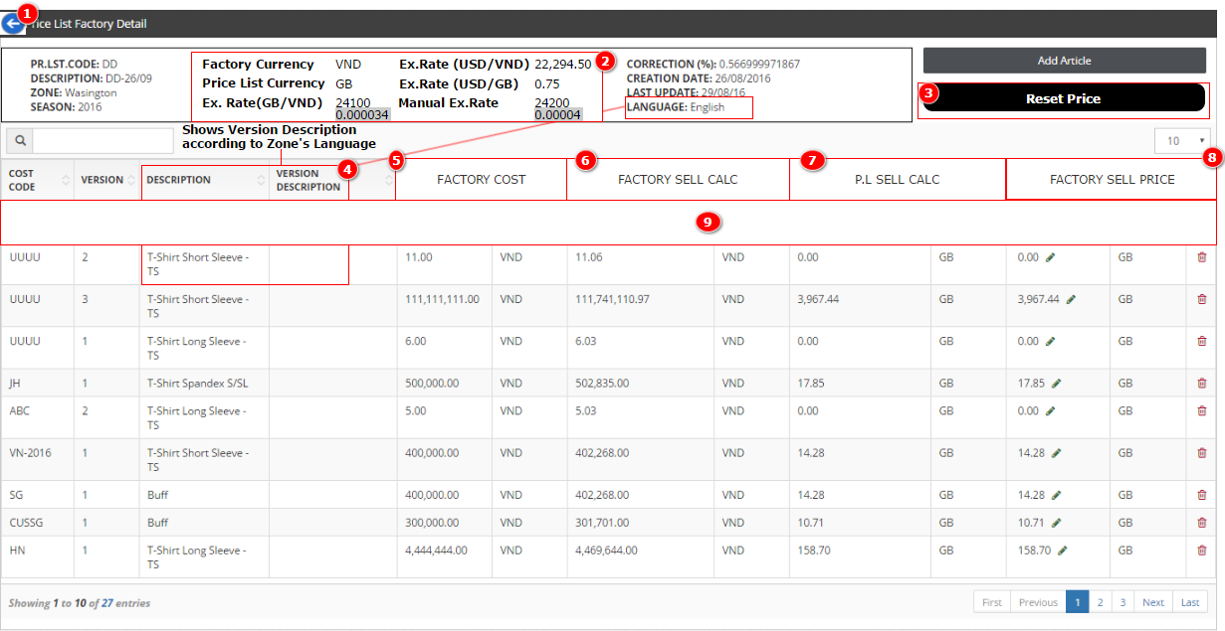

1. Components

|  |  |  |
| --- | --- | --- |
| **Component** | **Type** | **Description** |
| (1) | Button | Back to Price List Factory List. Keep previous state |
| (2) | Labels | Show exchange rate information |
| (3) | Button | User click on this button to reset all manual prices to sell prices. Show confirmation window before proceeding the reset action |
| (4) | Label | Show Costing’s description and Costing’s Version description according to Zone’s language |
| (5), (6), (7) and (8) | Label | Merge Price and Currency header into 1 column |
| (9) | Filters | Support filter to each column |

## Price List Zone

### Price List Zone List

#### Create Price List Zone

1. Main Screen

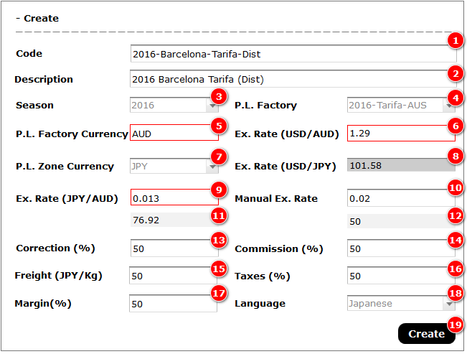

1. Components

|  |  |  |
| --- | --- | --- |
| **Component** | **Type** | **Description** |
| (1) | Text Field | Price List (P.L.) Code |
| (2) | Text Field | P.L.’s Description |
| (3) | Dropdown Box | P.L.’s Season |
| (4) | Dropdown Box | P.L. Factory |
| (5) | Label | P.L. Factory’s Currency |
| (6) | Label | P.L. Factory’s exchange rate based on USD |
| (7) | Dropdown Box | P.L. Zone’s Currency |
| (8) | Label | P.L. Zone ’s exchange rate based on USD |
| (9) | Label | Rate between Factory’s currency and P.L.’s currency.  (**9**) = (**6**) divided by (**8**) |
| (10) | Text Field | Manual rate between Factory’s currency and P.L.’s currency |
| (11) | Label | Inverse number of (**9**).  (**11**) = 1 / (**9**) |
| (12) | Label | Inverse number of (**10**).  (**12**) = 1/ (**10**) |
| (13) | Text Field | P.L. Zone’s Correction |
| (14) | Text Field | P.L. Zone’s Commission |
| (15) | Text Field | P.L. Zone’s Freight |
| (16) | Text Field | P.L. Zone’s Taxes |
| (17) | Text Field | P.L. Zone’s Margin |
| (18) | Dropdown Box | P.L. Zone’s Language |
| (19) | Button | User clicks on this button to create new P.L. Factory |

1. Business Rules

|  |  |  |
| --- | --- | --- |
| **Index** | **Action** | **Rule** |
| 1 | Create new P.L. | * Price’s calculation is always based one muanual exchange rate (**10**) |
| 2 | Update P.L.’s figures | * Updating P.L. Zone’s figures won’t effect to its manual prices |

#### Create Price List Zone by Copy

1. Main Screen

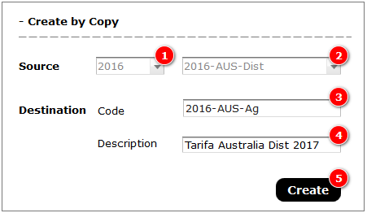

1. Components

|  |  |  |
| --- | --- | --- |
| **Component** | **Type** | **Description** |
| (1) | Dropdown Box | Source Seasons |
| (2) | Dropdown Box | Source P.L. Zones |
| (3) | Text Field | Destination’s P.L. Zone’s Code |
| (4) | Text Field | Destination’s P.L. Zone’s Description |
| (5) | Button | User clicks on this button to create new price list by copying from source P.L. Zone |

1. Business Rules

|  |  |  |
| --- | --- | --- |
| **Index** | **Action** | **Rule** |
| 1 | Create new P.L. Zone | * All information of source P.L. Zone will be copied to destination one |

### Price List Zone Detail

1. Main Screen

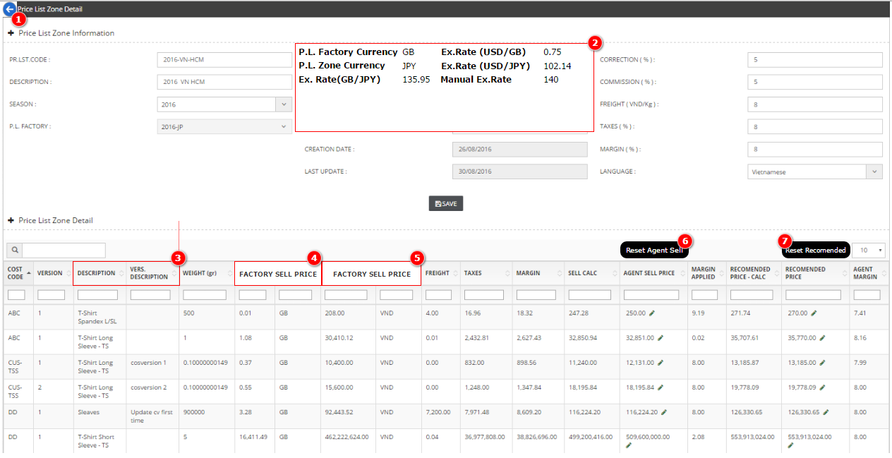

1. Components

|  |  |  |
| --- | --- | --- |
| **Component** | **Type** | **Description** |
| (1) | Button | Back to P.L. Zone List, previous state |
| (2) | Labels | Shows information related to P.L. exchange rate |
| (3) | Labels | Shows Costing’s description and Costing’ Version’s description according to P.L. Zone’s language |
| (4), (5) | Labels | Merge Price and Currency header into 1 column |
| (6) | Button | User clicks on this button to reset Agent Sell Price to Agent Calc Price. Show confirmation window before proceeding reset action |
| (7) | Button | User clicks on this button to reset Recomended Sell Price to Recommended Price Calc. Show confirmation window before proceeding reset action |

# Order

## Creating Order

### Main Screen

#### Line View

1. Layout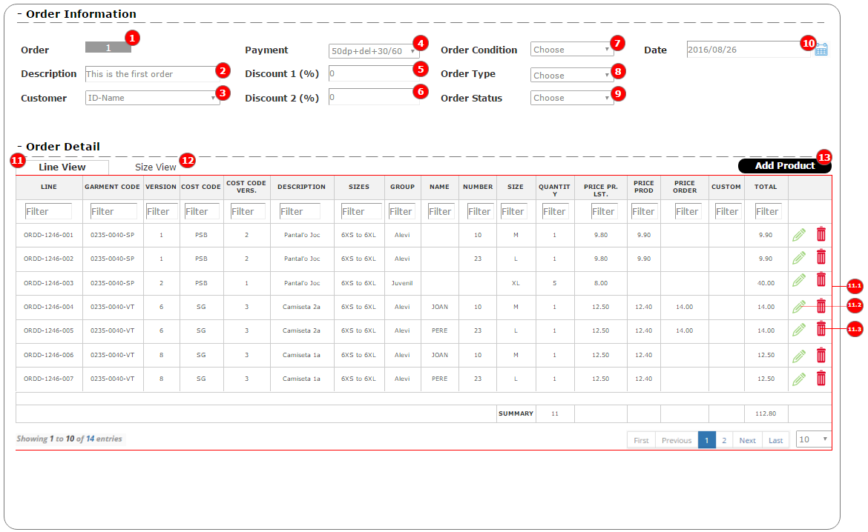
2. Components

|  |  |  |
| --- | --- | --- |
| **Component** | **Type** | **Description** |
| (1) | Label | Order’s Number. Automatically generated |
| (2) | Text Field | Order’s description |
| (3) | Dropdown Box | Customers List |
| (4) | Dropdown Box | Payments List |
| (5) | Text Field | Order’s Discount 1 |
| (6) | Text Field | Order’s Discount 2 |
| (7) | Dropdown Box | Order’s Conditions |
| (8) | Dropdown Box | Order’s Types |
| (9) | Dropdown Box | Order’s Statuses |
| (10) | Text Field | Order’s creation date |
| (11) | Tab View | Show Order Detail by Line |
| (11.1) | Grid | Show list of order details |
| (12) | Tab View | Show Order Detail by Size |
| (13) | Button | Click to open Add Product popup |

#### Size View

1. Layout

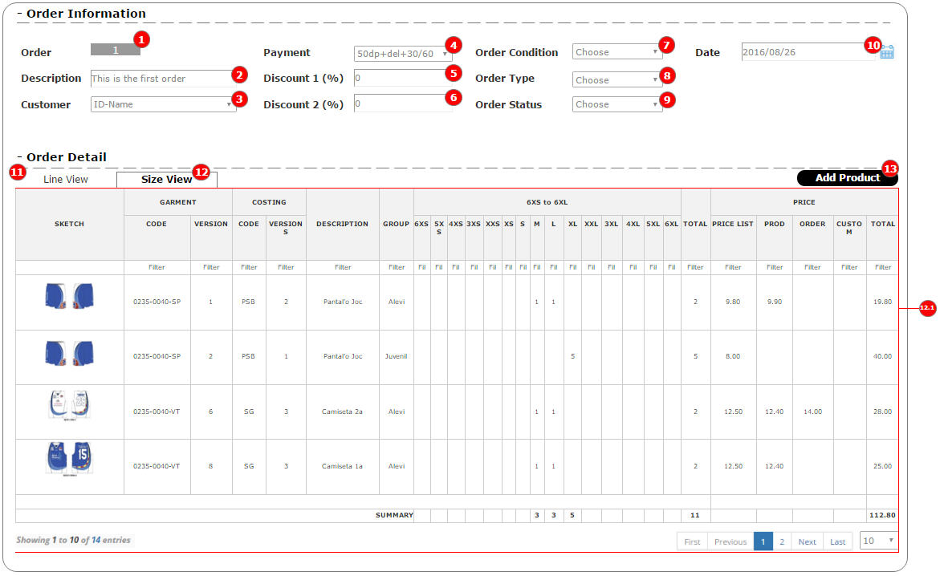

1. Components

|  |  |  |
| --- | --- | --- |
| **Component** | **Type** | **Description** |
| (11) | Tab View | Show Order Detail by Line |
| (12) | Tab View | Show Order Detail by Size |
| (12.1) | Grid | List of Order Details |
| (13) | Button | Click to open Add Product popup |

### Adding Product

#### Adding Product by Size quantity

1. Layout

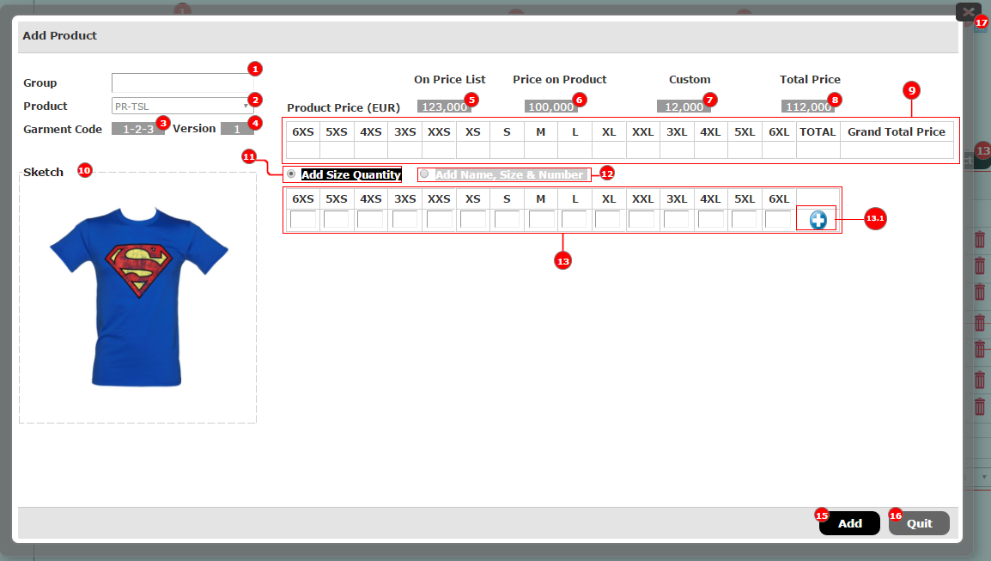

1. Components

|  |  |  |
| --- | --- | --- |
| **Component** | **Type** | **Description** |
| (1) | Text Field | Product’s Group |
| (2) | Dropdown Box | List of Products |
| (3) | Label | Garment Code |
| (4) | Label | Garment’s version |
| (5) | Label | Product’s price On Price List |
| (6) | Label | Product’s manual price |
| (7) | Label | Product’s custom price |
| (8) | Label | Product’s total price |
| (9) | Grid | Show quantity of each product’s size |
| (11) | Radio Button | Click to add product by Size quantity |
| (12) | Radio Button | Click to add product by Name, Number and Size |
| (13) | Grid | Contains list of text fields that allow user to input quantity of each size |
| (13.1) | Button | Click to add data into (9) |

#### Adding Product by Name, Number and Size

1. Layout

* Main Layout

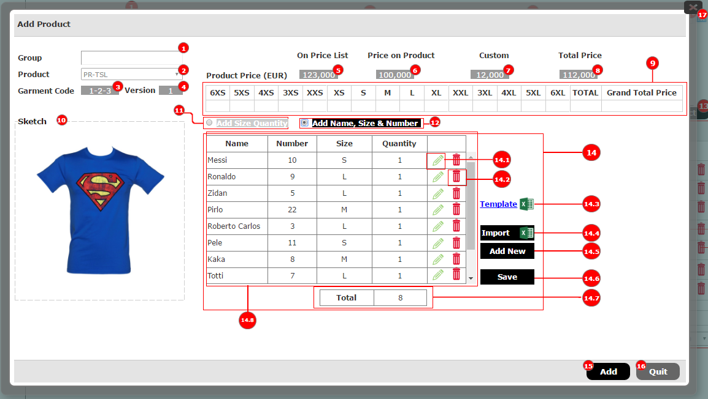

* Add Name, Number, Size and Quantity Popup

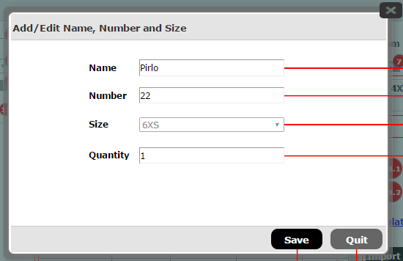

1. Components

|  |  |  |
| --- | --- | --- |
| **Component** | **Type** | **Description** |
| (9) | Grid | Show quantity of each product’s size |
| (11) | Radio Button | Click to add product by Size quantity |
| (12) | Radio Button | Click to open area that allows to add product by Name, Number and Size |
| (14) | Tab Content | Area to add product by Name, Number and Size |
| (14.1) | Button | Open “Name, Number and Size” popup to edit being chosen record |
| (14.2) | Button | Delete being chosen record |
| (14.3) | Link | Click to download Excel template. This template will enable user to add Name, Number, Size and Quantity by batch |
| (14.4) | Button | Support user to add “Name, Number, Size and Quantity” by batch |
| (14.5) | Button | Click to open “Name, Number and Size” popup to add new record to grid (14.8) |
| (14.6) | Button | Click to save data to (9) |
| (14.8) | Grid | Show list of “Name, Number, Size and Quantity” |